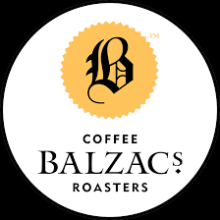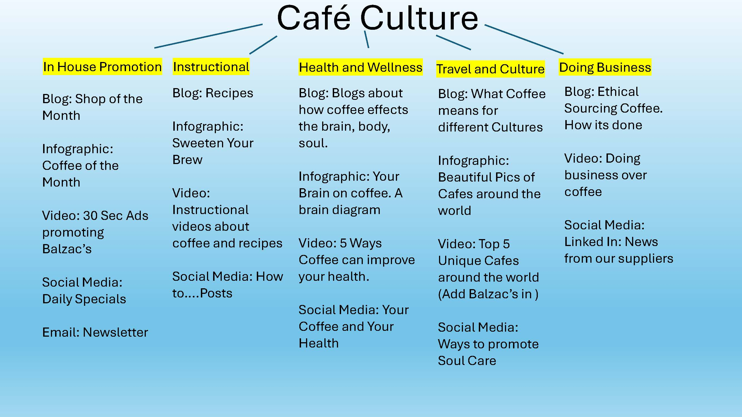
1. YouTube Ad
The following 20-second advertisement is designed for use in YouTube ad campaigns. It is composed of stock footage sourced from the Motion Array website. The voiceover is also an AI voice from Motion Array. The script and editing were done by Rebecca Korhonen. The music is a track from Universal Music titled UPM_NTP457_5_The_Good_Life_Instrumental_Wright_2049524.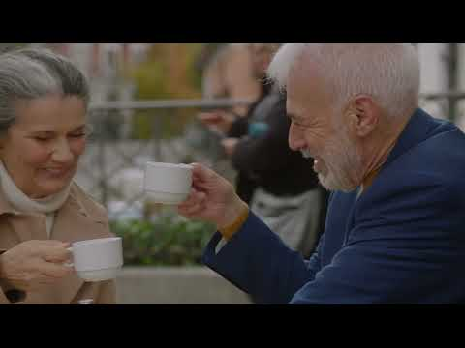
- Facebook and Instagram Coffee of the Month Campaign.
The Caption will read:
Balzac’s Coffee is proud to announce Junes Coffee of the Month is a Dark Affair. Hushed voices in the corners of the café are starting to brew with this delightfully dark roast. Enjoy its surprisingly smooth and rich aromas as you meet with a secret colleague for deep discussion and debate. This coffee is not only cracked once but twice in order bring out is sinfully good dark side. So come out and live on the shady side with this months coffee feature A Dark Affair.
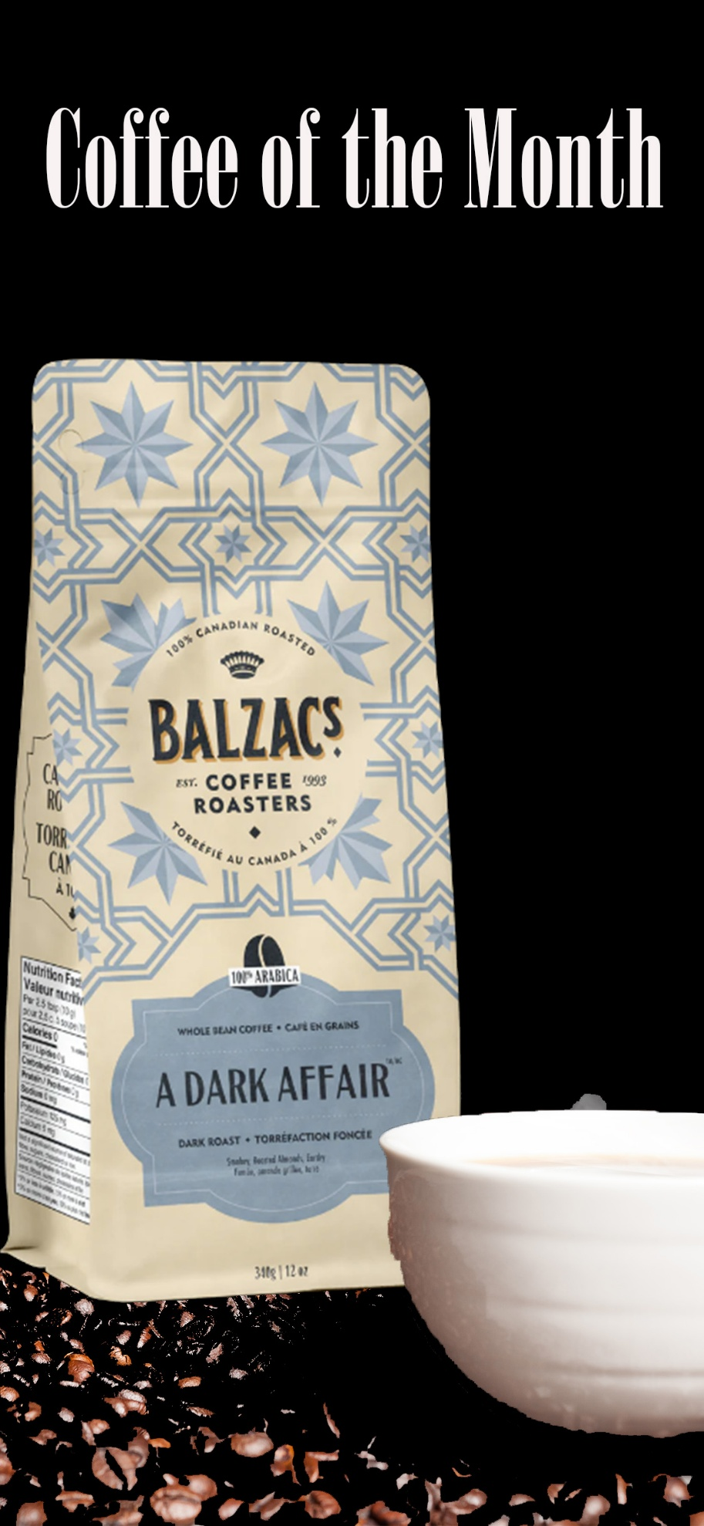
Content Calendar
Platform | Title | Topic | Topic Frequency | Content | Due Date | Audience
LinkedIn | How to Ethically Source Coffee | Coffee Commerce | Bi-Monthly | A post about how to Ethically source coffee | June 2nd 2025 | Business Professionals
Email Marketing | June’s Newsletter | Topics in June covered by Blogs. As well as news about specials in the Cafe | 1 per Month | Blogs and Specials | June 2nd 2025 | Business Professionals
Blog Post | How Coffee Stimulates the Brain | Health and Wellness | 1 per week | A study on coffee and the brain | June 3rd 2025 | Freelancers
Facebook | The Balzac Freelancer group | Joining a community | 1 per Week | All about joining the Balzac Freelancer Group | June 4th 2025 | Freelancers
Instagram | It’s Coffee Time | Promo Meme | 1 Per Week | An ad showing a hot cup of coffee | June 5th 2025 | Foodies and Hipsters
Blog | Paris Café Culture | Travel and Culture | 1 Per Week | An article about the Paris Way of life | June 5th 2025 | Foodies and Hipsters
TikTok | 5 Ways to Sip Coffee | Instructional | 1 Per Week | 5 humorous ways on how to sip coffee. | June 5th 2025 | Foodies and Hipsters
YouTube | Coffee Cake Recipe | Recipe | 1 per Month | A 2-3 min video on how to make Coffee Cake | June 1st 2025 | Coffee Lovers
Blog Post | Coffee Cake Recipe | Recipe | 1 per Month | 2-3 min video on how to make Coffee Cake | June 1st 2025 | Coffee Lovers
Facebook  Instagram  Website Landing Page | A Dark Affair | Coffee of the Month | 1 per Month | Poster of Coffee of the month with a descriptor paragraph. | June 9th 2025 | Coffee Lovers, Online Shoppers
Blog Post | How to plan your first meeting | Dating | Every second Month | An Article on Dating | June 20th 2025 | First Dater
Face Book  Instagram  Blog Post | Our Stratford Location | Locations | Every Month | Photos of the Stratford Location and a description in the blog | June 25th 2025 | Foodies, Coffee Lovers,

Reflection
My Ideation Process
Balzac’s Coffee Roasters has a clear goal and mission statement:
Inspired by the Grand Cafés of Paris, Balzac’s Coffee Roasters was brought to life by a burning ambition to bring that culture to Canada.
Based on my target audience personas — Business Professionals, Freelancers, Foodies, Coffee Lovers, First Daters, and Online Shoppers — I created a content schedule designed to cater to each of their needs. My mind map outlines content that touches the lives of these diverse groups, all grounded in a unifying theme: Café Culture. This concept sits at the heart of every Balzac’s experience. From there, I explored subtopics that break down the cultural essence into actionable content pillars.

In-House Promotion
The café needs to continuously promote itself and stay top of mind. Through monthly blogs and social media posts that spotlight one of the 16 unique locations and the wide variety of coffee offerings, content remains fresh and informative — letting customers know where Balzac’s is and what it offers.
YouTube ads are short, engaging, and designed to be watched — not skipped.

Instructional Content
This pillar appeals to foodies and coffee lovers who enjoy beautiful food imagery and want to try new recipes. Instagram and Facebook are great for photos and short tips, while YouTube and TikTok serve well for step-by-step recipe videos.

Health and Wellness
Café visitors are also health-conscious. They care about what their coffee does for their brain, body, and soul. Balzac’s can build trust by being transparent about sourcing and health benefits. This also creates an opportunity to showcase the brand's ethically sourced products and ingredients.

Travel and Culture
You can’t bring a Parisian café vibe without sharing the culture behind it. Blog posts that explore European café culture or profile inspiring cafés worldwide help solidify Balzac’s as an authentic cultural experience — not just a coffee shop. These stories elevate the brand to a Canadian equivalent of the Parisian café.

Doing Business
Content like blogs, posts, and videos on “Doing Business in a Café” will appeal to professionals looking for productive, stylish spaces outside the boardroom. Positioning Balzac’s as a “second office” with better coffee is a win.

Tools for Generating Content
Blogs: Google Docs, Microsoft Word, ChatGPT (for spelling and grammar refinement)
Infographics: Canva, Photoshop, Google Suite
Video: Adobe Premiere Pro, After Effects for editing; Universal Music and Motion Array for stock music and footage; DSLR cameras, lighting, and microphones for in-house shoots; cell phones for informal content
Social Media: Facebook, Instagram, LinkedIn (Balzac’s currently does not use X/Twitter)
Email: Mailchimp or Hootsuite for email campaigns and scheduling

Taxonomy and Tagging Framework
1. Café Culture Taxonomy Structure
Category | Sub-Categories
Café Promotions | Featured Coffee, Featured Locations, Menus, Daily Specials
Instructional | Recipes, Coffee Brewing, Strategies
Health and Wellness | Brain, Body, Soul
Travel and Culture | Paris Café, Cafés Worldwide
Business in the Café | Ethically Sourced, Meeting Etiquette

2. Tagging Framework (Faceted Metadata)
Product Tags:
• Roast Profile: Light, Medium, Dark
• Bean Type: Single-Origin, Blend, Organic, Fairtrade
• Flavor Notes: Chocolatey, Fruity, Nutty, Spicy
• Seasonality: Winter Feature, Spring Launch, Limited-Time
• Format: Whole Bean, Ground, Canned, Ready-to-Drink
• Dietary: Vegan, Gluten-Free, Contains Dairy
• Serving Style: Hot, Iced, Bottle
Content Tags (for Blogs/News/Recipes):
• Ontario Cafés
• Recipes with Coffee
• Café Openings
• Staff Spotlights
• Behind the Scenes
• Ethically Sourced
• Community Partnerships

3. Video Metadata Examples
Location Tags:
• Stratford, Liberty Village, Niagara-on-the-Lake, Distillery District, etc.
Topic Tags:
• Recipes: Cocktails, Muffins, Brownies, Coffee
• Mind: Brain Health, Stimulants, Caffeine
• Business: Ethically Sourced, Boardroom, Meetings
• Balzac’s Coffee: Specials, Features, Paris, Café

